Dispatch No. 300 | 21 May 2019

# **Ugandans support gender equality, but women participation in governance still trails**

## **Liberty Christopher**

Women have a right to engage in their country’s political processes, take part in elections, be elected to a government office, serve on boards, and participate in civic activities which will affect their lives, families, and their communities. Ensuring that girls and women participate in political activities in their country may be a necessary step to achieving the United Nations’ (2019) Sustainable Development Goal No. 5: “Achieve gender equality and empower all women and girls.”

In Uganda, government efforts to achieve gender equality include a National Gender Policy (2007), a Gender and Equity Strategy for Social Protection (2018), and a range of program interventions emphasizing women’s empowerment, like the Uganda Women Entrepreneurship Programme, Labour program, and Youth Livelihood Program (Uganda Bureau of Statistics, 2019). But despite notable efforts, women still lag behind men in access to political and socio-economic opportunities.

According to the United Nations Development Programme’s Human Development Report (<http://hdr.undp.org/sites/all/themes/hdr_theme/country-notes/UGA.pdf>), Uganda has a Gender Development Index value of 0.531, ranking at 127 out of 162 countries in the 2018 index. Being among the 40 countries with the lowest Gender Development Index shows that few women are participating in socio-economic and political development of the country. Moreover, women remain susceptible to gender-based violence, own fewer assets than men, makeup just 35% of Parliament, and are less likely than men to have paid employment (28% vs. 46%) (Uganda Bureau of Statistics, 2017a, 2017b, 2019; Gabola et al., 2018; Wyrod, 2008).

According to the Afrobarometer survey (2016-2018), most Ugandans support gender equality and, 79% of Ugandans say equal opportunities and treatment for women have improved in recent years. A majority think that men should have an equivalent chance of being elected to political office as men. (Afrobarometer R7).

The feminism has most certainly caused fundamental changes for women including more freedom, fairness within the workplace, and equal social standing. However, one cannot help but notice that women aren't only underrepresented within the political arena, but it's continuously becoming difficult for them to participate fully in governance processes as they score lowly in most of the measurable indicators of political participation.

According to UN Women, participation in governance practices involves far more than simply voting. Political participation derives from the freedom of speech, assemble and associate; the power to take part in the conduct of public affairs; and therefore, the opportunity to register as a candidate, to campaign, to be elected, and to hold office at all levels of government. Under international standards, men and women have an equal right to participate fully altogether in aspects of the political process. In practice, however, it is often harder for women to exercise this right.

<https://www.un.org/womenwatch/osagi/wps/publication/Chapter3.htm> <https://au.int/sites/default/files/newsevents/conceptnotes/38737-cn-concept_note-_high_level_forum_on_the_launch_of_the_initiative_wgpp.pdf>

<https://www.idea.int/sites/default/files/publications/african-union-mechanisms-to-foster-gender-mainstreaming-and-ensure-womens-political-participation.pdf>

<https://africa.cgtn.com/2020/10/18/african-women-enjoying-increasing-participation-in-politics-au/>

In an effort to empower women and enhance their participation in elective politics, the 1995 Constitution of Uganda in Article 78(b) created special interest parliamentary positions reserved for women at the district level. Despite the creation of these quotas, women are still marginalized in politics and their participation has not been brought to the fore.

**Afrobarometer surveys**

Afrobarometer directs a pan-African, nonpartisan research network that conducts public attitude surveys on democracy, governance, economic conditions, and related issues in African countries. Seven rounds of surveys were completed in up to 38 countries between 1999 and 2018. Round 8 surveys in 2019/2020 are planned in at least 35 countries. Afrobarometer conducts face-to-face interviews in the language of the respondent’s choice with nationally representative samples.

The Afrobarometer team in [country], led by [NP], interviewed [1,200/2,400] adults [citizens of this country] in [month year]. A sample of this size yields country-level results with a margin of error of +/-3 [or +/-2] percentage points at a 95% confidence level. Previous surveys were conducted in [country] in [years].

**Key findings**

* A considerably high percentage of women (39%) responded that they would never discuss political matters once they are either with their friends or relations
* The majority of Ugandans believe that women should have an equivalent chance of being elected to political office as men
* 76% of respondents say women should have an equal chance as men of being elected to political office
* More Males would occasionally discuss political matters once they get together with their friends or family compared to Females
* 63% of Ugandans say that equal opportunities and treatment of women is better than it was a few years ago
* A sizeable portion of women of say they have never got news from the radio (20%)

**Political leadership for women in Uganda**

A majority of Ugandans support gender equality, but some respondents think that men make better leaders than women. A high percentage (76%) of respondents say women should have an equivalent chance as men of being elected to political office. but less than a quarter of Ugandans (22%) think men make better political leaders than women and should be elected in their place

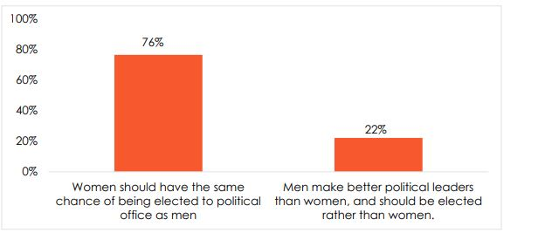**Respondents were asked:** Which of the following statements is closest to your view? (% Who “agree” or “agree very strongly” with each statement)

**Figure 1: Support for gender equality in politics** | Uganda | 2016-2018

**Men as leaders v women as leaders**

Many of the respondents think that women should have the same chance of being elected to political office as men albeit more respondents within the urban areas agree very strongly (63%) compared to 60% in rural areas that women have an equivalent chance as men. A small number of respondents in rural areas (17%) say that Men make better political leaders than women, and should be elected instead of women. Relatedly, one out of ten respondents in urban areas think that Men make better political leaders than women, and should be elected rather than women

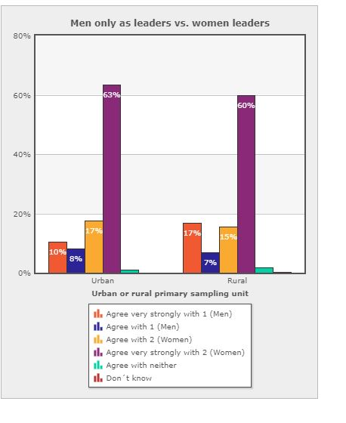

***Respondents were asked:*** *Men only as leaders vs. women leaders*

*Statement 1: Men make better political leaders than women, and should be elected rather than women. Statement 2: Women should have the same chance of being elected to political office as men.*

**Figure 2: Men only as leaders vs. women leaders** | Uganda | 2016-2018

**Handling promoting equal rights/opportunities for women**

About 8% have noted a fall off within the Ugandan government’s promotion of opportunities and equality for women. In contrast, 26% of Uganda believe that Uganda has recorded an improvement in availing equal rights and opportunities for women. Better still, six out of ten respondents say Uganda’s efforts to promote gender equality have stayed an equivalent between 2016 and 2018. Overall, Ugandan citizens perceive that Uganda’s support for equal rights, gender equality, and promoting opportunities for women has stayed on a constant course.

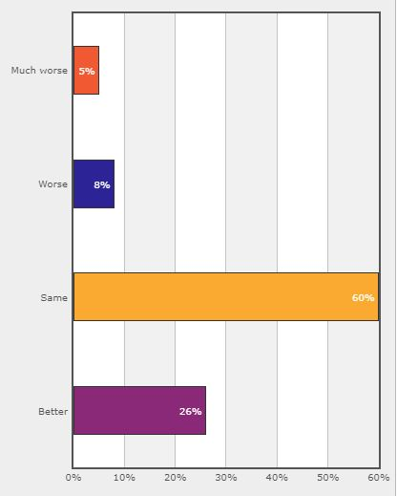

*Respondents were asked: How well or badly would you say the current government is handling the following matters, or haven’t you heard enough to say? Promoting opportunities and equality for women?*

**Figure 3: Handling promoting equal rights/opportunities for women | Uganda | 2016-2018**

**Equal opportunities and treatment for women**

Afrobarometer also sought to understand whether things are worse or better now than they were a couple of years ago, or whether they were about the same concerning equal opportunities and treatment for women. About one in twenty say things are worse concerning equal opportunities and treatment of women (6%), whereas slightly more than a quarter of the respondents (17%) think the provision of equal opportunities and treatment for women have become so much better than they were before. Conversely, the highest percentage of the respondents say equal opportunities and treatment of women is better than it was a couple of years ago (63%)

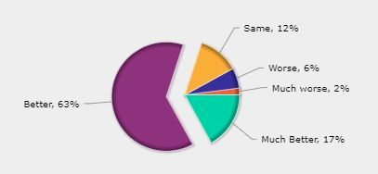

**Figure 4: Better or worse: equal opportunities and treatment for women**

*Respondents were asked: Please tell me if the following things are worse or better now than they were a few years ago, or are they about the same? Equal opportunities and treatment for women*

**Discussing politics**

When it comes to discussing issues that pertain to politics, Men are more engaged compared to women since the 2016-2018 Afrobarometer survey indicates that 55% of male respondents say they occasionally discuss political matters with their friends or family members. A high percentage of women (39%) responded that they would never discuss political matters once they are either with their friends or family members. By contrast, male respondents tend to debate political matters frequently far more than women (20% v 9%).

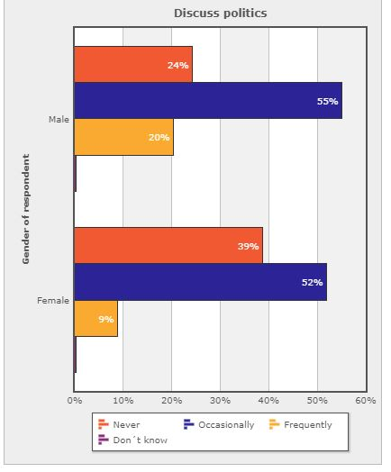

***Respondents were asked:*** *Discuss politics*

*When you get together with your friends or family, would you say you discuss political matters.*

**Figure 5: Discuss Politics** | Uganda | 2016-2018

**Information access**

According to the Uganda Communication Commission, listenership figures show that the radio is the most popular medium in Uganda. With regard to information access, slightly over three-fifths of Ugandan men (61%) say they get news from the radio every day. Round 7 survey conducted by Afrobarometer in Uganda further indicates that a higher portion of radios in Uganda are owned by males compared to females (72% v 63%). On the opposite hand, only four in ten (43%) of women say they get news from radio daily with about 20% of women stating they have never got news from the radio.

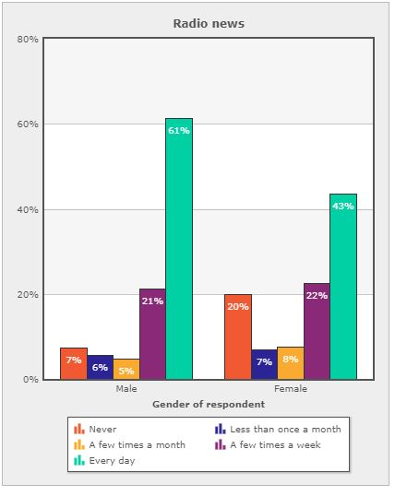

***Respondents were asked****: How often do you get news from the following sources? Radio*

**Figure 6: How often do you get news from the following sources? Radio** | Uganda | 2016-2018

**Last national election: attend a campaign rally**

When it comes to participation in national elections, specifically on whether Ugandans attend campaign rallies, more citizens in rural areas attend campaign rallies (62%) compared to 57% in urban areas. Women are slightly less likely to attend a campaign rally than men; 61% vs. 55% (R7). In Afrobarometer’s Round 5 survey, 69% of Males said they attended a political campaign compared to 48% of Females. This denotes a slight improvement in women’s participation in governance processes.

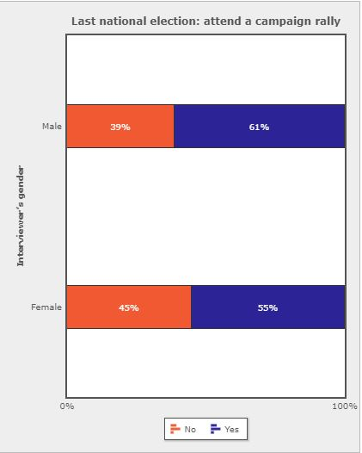

*Last national election: attend a campaign rally*

***Respondents were asked:*** *Thinking about the last national election in 2013, did you: Attend a campaign rally?*

**Figure 7: Thinking about the last national election in 2013, did you: Attend a campaign rally?** | Uganda | 2016-2018

**Conclusion**

Uganda widely supports equal opportunities and rights for women. The majority of citizens (76%) say women should have an equivalent chance as men of being elected to political office. Although most respondents are in favor of women’s equal rights when it comes to attending political campaigns and access to information, women fall far behind their male counterparts. More so, about 39% of women say that they would never discuss political matters when they are either with their friends or family members. For policymakers and civil society, these findings point to a need for strategies to improve women's involvement in governance policies for gender-responsive and sustainable socio-economic and political development.

**References**

Al Jazeera. (2013).[Who killed Tunisia's Chokri Belaid?](https://www.aljazeera.com/indepth/features/2013/09/201394183325728267.html) 12 September..

Arab Weekly. (2019). [Tunisian security forces stymie jihadists’ effort to forge new ‘emirate.’](https://thearabweekly.com/tunisian-security-forces-stymie-jihadists-effort-forge-new-emirate) 5 January..

BBC News. (2017). [Tunisia profile – timeline. A chronology of key events](https://www.bbc.com/news/world-africa-14107720). 1 November..

BBC News. (2018). Tunis attack: Woman blows herself up in Tunisia. <https://www.bbc.com/news/world-africa-46017905>.

Bremmer, I. (2017). [The top 5 countries where ISIS gets its foreign recruits](http://time.com/4739488/isis-iraq-syria-tunisia-saudi-arabia-russia/). 14 April.

Meko, T. (2018). [Now that the Islamic State has fallen in Iraq and Syria, where are all its fighters going?](https://www.washingtonpost.com/graphics/2018/world/isis-returning-fighters/) Washington Post..

Middle East Monitor. (2019a). [Tunisia protests against ‘government policies.’](https://www.middleeastmonitor.com/20190405-tunisia-protests-against-government-policies/) 5 April.

**[ Author’s Name ]** is [title] for [organisation] in [location]. Email: [address].

**[ Author’s Name ]** is [title] for [organisation] in [location]. Email: [address].

Afrobarometer, a nonprofit corporation with headquarters in Ghana, directs a pan-African, non-partisan research network. Regional coordination of national partners in about 35 countries is provided by the Ghana Center for Democratic Development (CDD-Ghana), the Institute for Justice and Reconciliation (IJR) in South Africa, and the Institute for Development Studies (IDS) at the University of Nairobi in Kenya. Michigan State University (MSU) and the University of Cape Town (UCT) provide technical support to the network.

Financial support for Afrobarometer Round 8 has been provided by the Swedish International Development Cooperation Agency (SIDA), the Mo Ibrahim Foundation, the Open Society Foundations, the William and Flora Hewlett Foundation, and the U.S. Agency for International Development (USAID) via the U.S. Institute of Peace.

Donations help Afrobarometer give voice to African citizens. Please consider making a contribution (at www.afrobarometer.org) or contact Felix Biga (felixbiga@afrobarometer.org) to discuss institutional funding.

Follow our releases on #VoicesAfrica. Image result for facebook iconhttps://encrypted-tbn1.gstatic.com/images?q=tbn:ANd9GcQUwBmsPGtE8Tqai7o6FY29JyXi5cBkzJsNcelpuCahg35VxCL-2TaFNd_k6wImage result for twitter icon

/Afrobarometer @Afrobarometer

**Afrobarometer Dispatch No. X | XX Month 2017**